

| Course Number | COE691 |
| --- | --- |
| Course Title | Software Requirements Analysis and SPEC |
| Semester/Year | Winter Semester 2024 |
| Instructor | Dr. Rasha Kashef |
| TA Name | Aman Yadav |

| Lab/Tutorial Report No. | Lab 1 |
| --- | --- |

| Report Title | Lab 1: Buy & Sell Magazine Exchange |
| --- | --- |

| Section No. | 06 |
| --- | --- |
| Submission Date | Friday, February 2nd, 2024 |
| Due Date | Friday, February 2nd, 2024 |

| Student Name | Student ID | Signature* |
| --- | --- | --- |
| [Hamza Malik](mailto:hamza.ejaz.malik@ryerson.ca) | 501112545 | HM |

*\*By signing above you attest that you have contributed to this submission and confirm that all work you have contributed to this submission is your own work. Any suspicion of copying or plagiarism in this work will result in an investigation of Academic Misconduct and may result in a “0” on the work, an “F” in the course, or possibly more severe penalties, as well as a Disciplinary Notice on your academic record under the Student Code of Academic Conduct, which can be found online at:* [*http://www.ryerson.ca/content/dam/senate/policies/pol60.pdf*](http://www.ryerson.ca/content/dam/senate/policies/pol60.pdf)

**For the “Buy & Sell Magazine Exchange” case, develop the following:**

**1. A list of use cases and a use case diagram.**

**Use Cases:**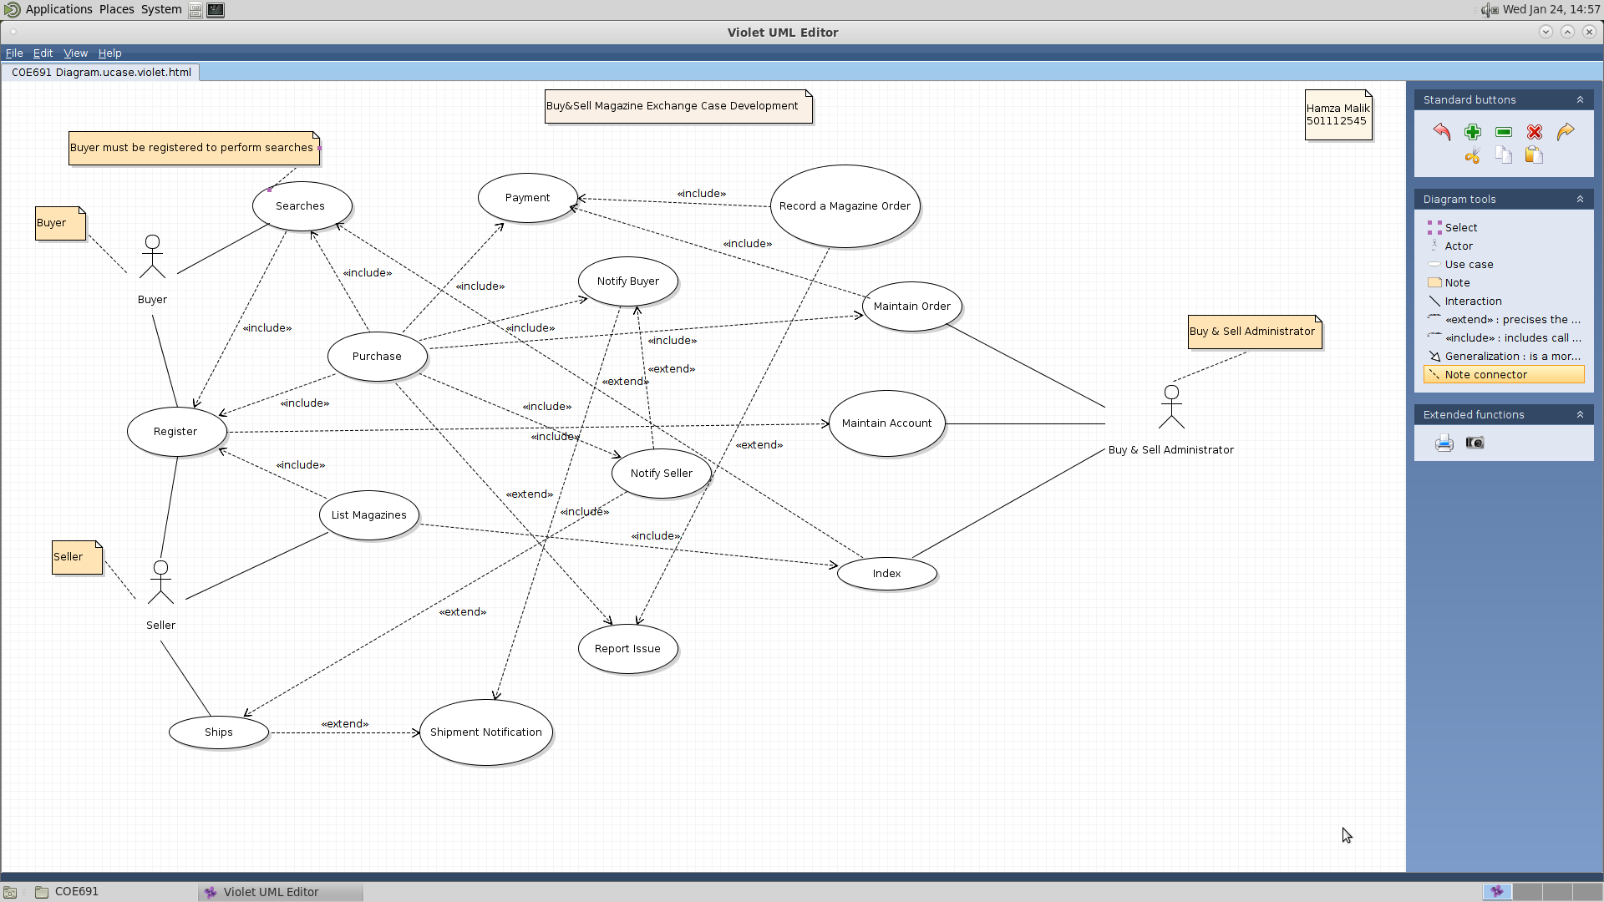

1. **Searches:** A registered buyer can search available magazines in the system.
2. **Register:** Enables new users to create an account to become buyers or sellers.
3. **Ships:** Used by the seller to log the dispatch of magazines to the buyer.
4. **List Magazines:** Allows sellers to list the magazines they want to sell on the platform.
5. **Purchase:** Facilitates the buying process for the buyer to acquire magazines.
6. **Payment:** Handles the transaction process, ensuring buyers can pay.
7. **Notify Buyer:** Inform the buyer about updates or changes related to their orders.
8. **Notify Seller:** Alerts the seller about new orders or updates regarding their magazine listings.
9. **Report Issue:** Provides a way for users to report problems or concerns with the system or transactions.
10. **Maintain Order:** The Buy & Sell Administrator can update and manage order details post-purchase.
11. **Maintain Account:** Enables users to update or change their account details.
12. **Record a Magazine Order:** Captures and logs the details of a magazine purchase in the system.
13. **Index:** Allows the system to categorize and organize listings for efficient searching.
14. **Shipment Notification:** Used to inform the buyer that the magazines have been shipped.

### 

### **Actors:**

### **Buyer:** A registered user on the platform to purchase magazines.

### **Seller:** A registered user who lists magazines for sale and manages orders and shipments.

### **Buy & Sell Administrator:** The system role responsible for managing the overall process, including order records, notifications, and issue reports.

**2. A fully developed description for two use cases:**

**a. Add a Seller**

**Use Case Name:** Add a Seller

**Primary Actor:** Seller

In the "Add a Seller" use case, the primary actor is the seller who is interested in listing magazines for sale on the platform. The other key stakeholder is the Buy & Sell Administrator, who is responsible for ensuring that all sellers are verified and that the integrity of the marketplace is maintained. Before the use case begins, it must be ensured that the seller is not already registered in the system. The goal is to have the seller successfully registered and able to list magazines. The process starts when the seller engages the "Register" use case. The system then presents a registration form requiring the seller to input personal details and payment information for future transactions. Upon submission, the system validates this information. If any detail is incorrect, the system flags an error and prompts the seller to correct the information, then attempts to revalidate it. Once all information is accurate, the system establishes a new seller account and confirms successful registration to the seller. The seller is now ready to list magazines for sale, which is done through the "List Magazines" use case. This use case includes a special requirement that the registration form must be secured with CAPTCHA to prevent automated registrations, reflecting the platform's commitment to security. The frequency of occurrence for this use case is potentially high, as the marketplace could see multiple sellers seeking registration on any given day.

**b. Record a magazine order.**

**Use Case Name:** Record a Magazine Order

**Primary Actor:** Buy & Sell Administrator

The "Record a Magazine Order" use case primarily involves the Buy & Sell Administrator, with the buyer and seller as critical stakeholders. The buyer's interest is in acquiring magazines, whereas the seller's interest lies in the sales. The Buy & Sell Administrator plays a crucial role in ensuring that every order is recorded accurately and efficiently. This use case is contingent upon the buyer having selected magazines and completed the "Purchase" use case. The main success scenario unfolds as follows: After the buyer finalizes the purchase of the magazines, the system automatically initiates the "Record a Magazine Order" use case. It meticulously records all pertinent details such as the buyer's information, the specifics of the magazines ordered, and the payment confirmation. If the payment fails to process, the system alerts the buyer and prompts a retry for the payment. Following a successful transaction, the system updates the inventory accordingly and notifies the seller of the new order. It also ensures that the buyer receives an order confirmation. The system must be integrated with a reliable payment gateway to verify payments in real time for this process to function seamlessly. The frequency at which this use case occurs is directly tied to the volume of magazine sales on the platform, which could vary from day to day.

**3. A System Sequence Diagram for each of the two use cases in question 2.**

1. **Seller**

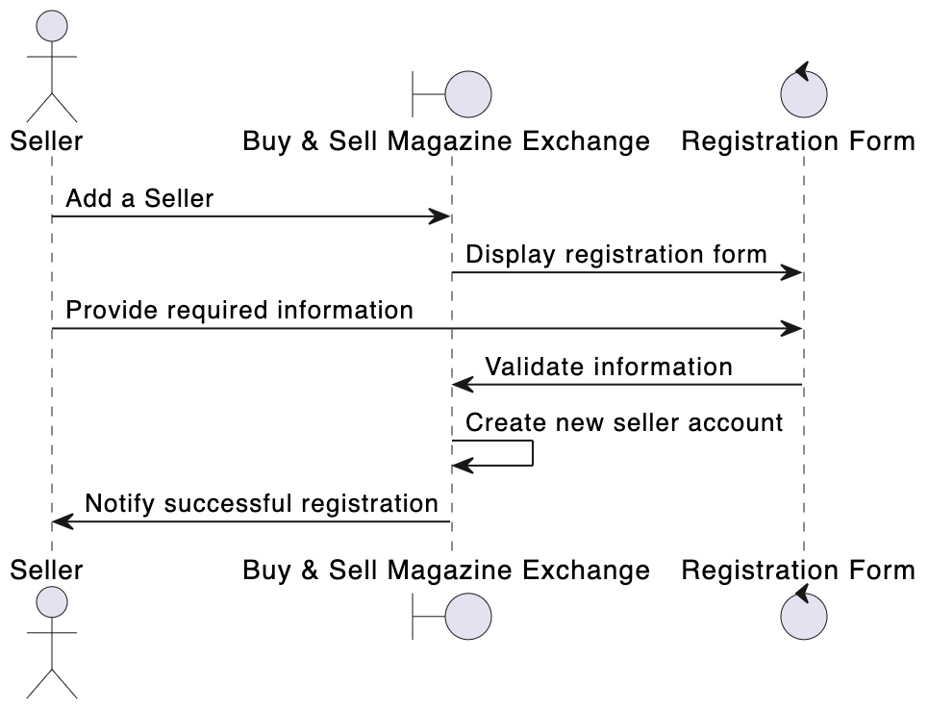

The "Buy & Sell Magazine Exchange" system's registration procedure for a seller is shown in the sequence diagram. First, the system displays a registration form when the seller initiates the registration process. The vendor then provides the registration with the necessary data. After verifying that all information is accurate, the system opens a new seller account. After successfully creating the account, the system notifies the seller, which completes the procedure. This procedure ensures the vendor is accurately registered in the system before the vendor can start selling.

1. **Buy & Sell Administrator**

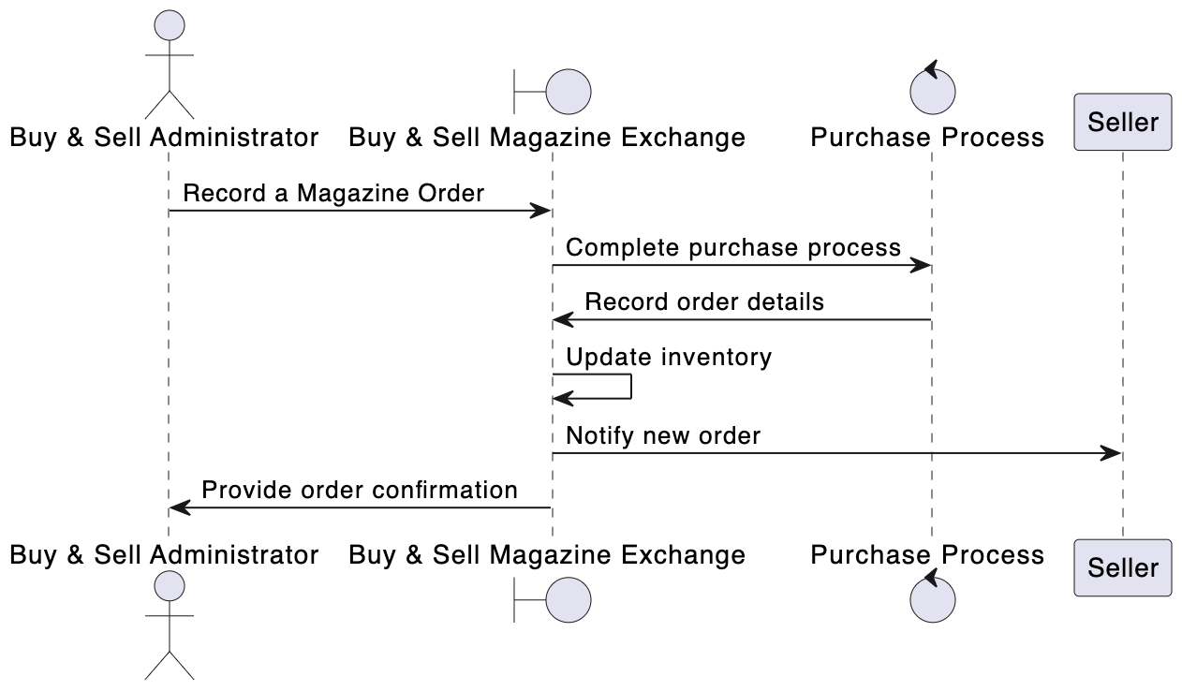

The procedures required to register a magazine order within the "Buy & Sell Magazine Exchange" system are shown in the sequence diagram for the "Buy & Sell Administrator" process. The Buy & Sell Administrator logs a magazine order to start the procedure. The system then finishes the purchase process, including updates to the order status and contacts with payment systems. After that, the order details are entered into the system, the inventory is updated to reflect the sale, and the seller is notified that a new order has been placed. Ultimately, the system returns the order confirmation to the Buy & Sell Administrator. Upon establishing a magazine order, this procedure ensures that all required actions are performed to document, handle, and validate the order, informing the administrator and the seller of the new transaction.